PENETRATION TESTING STYLE REPORT
OWASP Juice Shop – Controlled Practice Environment

Name: Aisha Aslam

Position: Cybersecurity Intern

Organization: Skillset Go EduTech

Offer ID: SSG/REG/B1/0166

1. Executive Summary
This report documents a security assessment performed in the authorized OWASP Juice Shop practice environment. The assessment focused on vulnerability identification, authentication and input-validation weaknesses, and session-management observations. The documented evidence shows an authentication bypass during SQL injection testing, execution of injected content during an XSS test, and an authentication-related token visible in browser Local Storage.

2. Scope and Environment
Target: OWASP Juice Shop
Environment: Controlled legal practice environment
Assessment purpose: Educational security testing and documentation
Testing areas: Authentication, input validation, and session management

3. Methodology
The assessment followed a basic penetration-testing style workflow: identify relevant application functionality, perform controlled tests against the practice environment, observe the application response, capture evidence, and document the security implications and recommended controls.
- Authentication testing through the login functionality.
- Input-validation testing through the search functionality.
- Browser-side session-management inspection using Chrome Developer Tools.
- Screenshot-based evidence collection with sensitive token content redacted.

4. Findings

Finding 01 – SQL Injection / Authentication Bypass
Test area: Login functionality
A SQL injection payload was used during controlled testing of the login functionality. The application accepted the crafted input and authentication was bypassed.
Potential impact: Unauthorized authentication within the tested application context.
Recommendation: Use parameterized queries/prepared statements and validate authentication inputs on the server side.
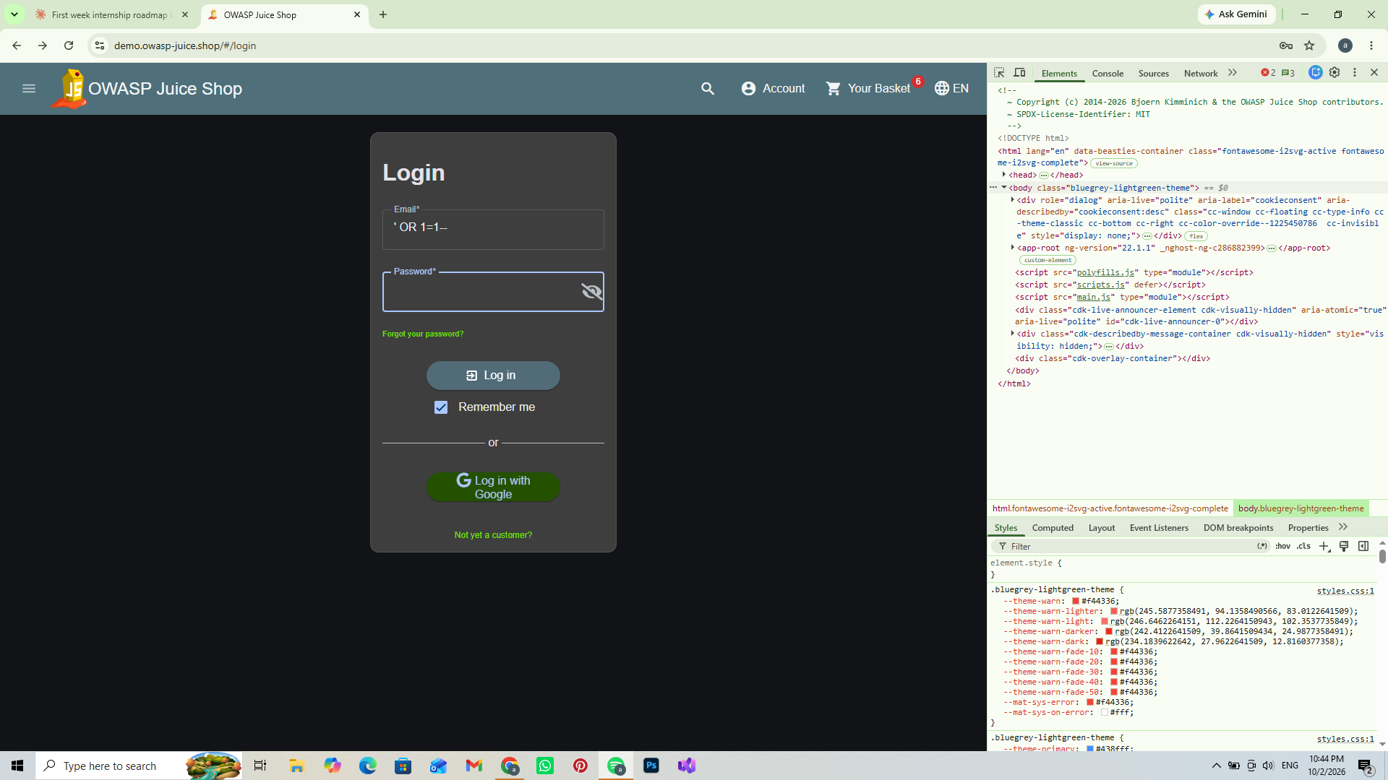
Figure 1 – Login authentication test evidence

Finding 02 – Cross-Site Scripting (XSS)
Test area: Search functionality
An XSS payload was entered into the search functionality. The injected content executed and an alert was displayed, demonstrating insufficient handling of user-supplied input in this test case.
Potential impact: Script execution in the application context and possible exposure of client-side data depending on application controls.
Recommendation: Apply strong server-side input validation and context-appropriate output encoding.
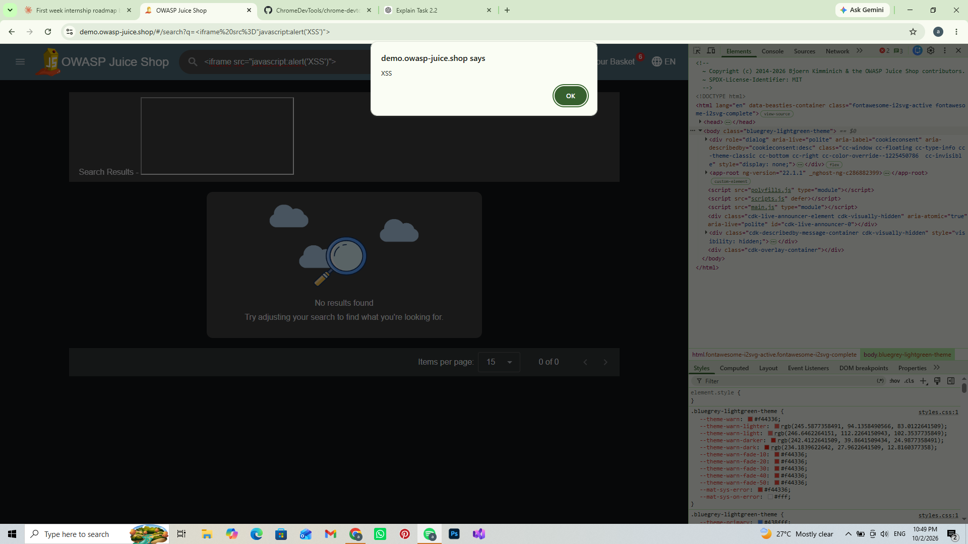
Figure 2 – XSS alert observed during search testing

Finding 03 – Session Management Observation
Test area: Browser Local Storage
After authentication, Chrome Developer Tools were used to inspect Local Storage. An authentication-related token was present in the Juice Shop domain's Local Storage. Browser-accessible token storage can increase exposure if malicious JavaScript executes in the same application context.
Potential impact: Increased exposure of authentication material in the browser context.
Recommendation: Use secure session-management practices and protect authentication tokens from unnecessary client-side exposure.
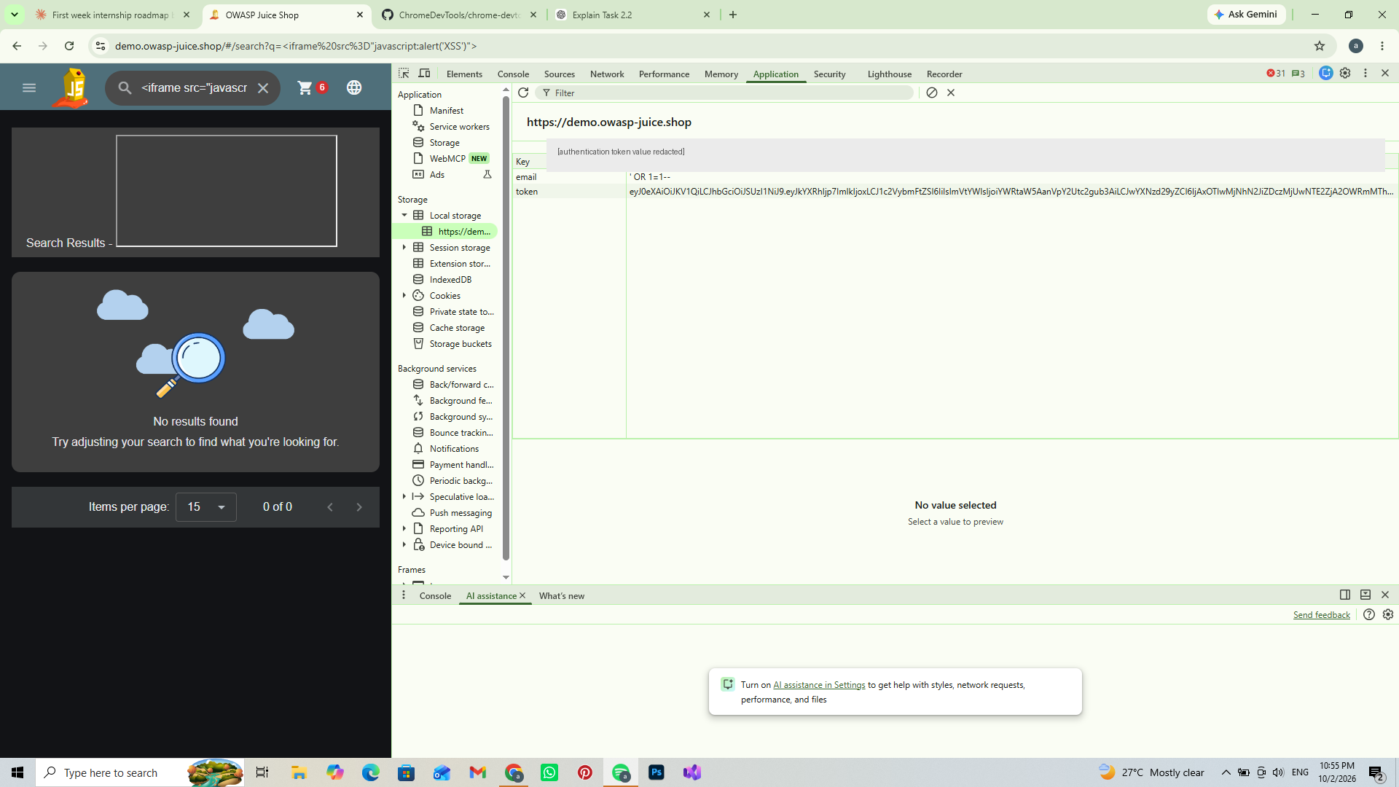
Figure 3 – Local Storage showing the authentication token key; token value redacted

5. Risk and Impact Summary
Finding | Observed Issue | Potential Impact
01 | SQL injection authentication bypass | Unauthorized authentication in the tested application context
02 | XSS execution in search | Script execution in the application context
03 | Authentication-related token in Local Storage | Increased client-side exposure of authentication material

6. Recommendations
- Use parameterized queries or prepared statements for database operations.
- Perform strong server-side validation of user-supplied input.
- Apply appropriate output encoding to prevent XSS.
- Use secure session-management practices.
- Protect authentication tokens from unnecessary client-side exposure.
- Keep security evidence documented and redact sensitive authentication values before sharing.

7. Evidence Summary
The report contains three evidence figures: the login authentication test, the XSS alert observed during search testing, and the Local Storage inspection. The authentication token value has been redacted and is not included in this report.

8. Conclusion
The controlled OWASP Juice Shop assessment demonstrated weaknesses involving authentication, input handling, and session-management exposure. The captured evidence supports the documented findings. The recommended controls focus on secure database queries, server-side input validation, output encoding, and appropriate protection of authentication/session material.

9. Assessment Limitation
This report is based only on the tests and evidence captured during the documented Week 2 practice-environment work. It does not claim that the application was exhaustively tested for all possible vulnerabilities.

